**Week 6**

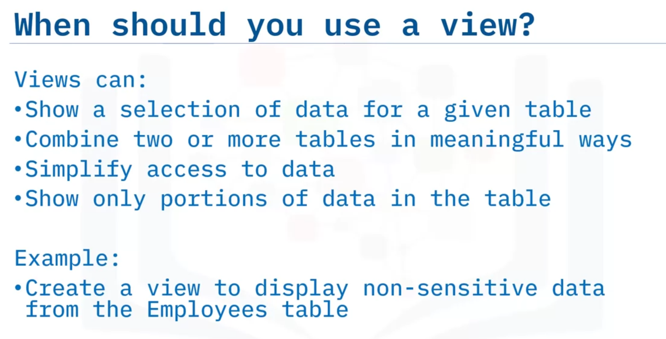

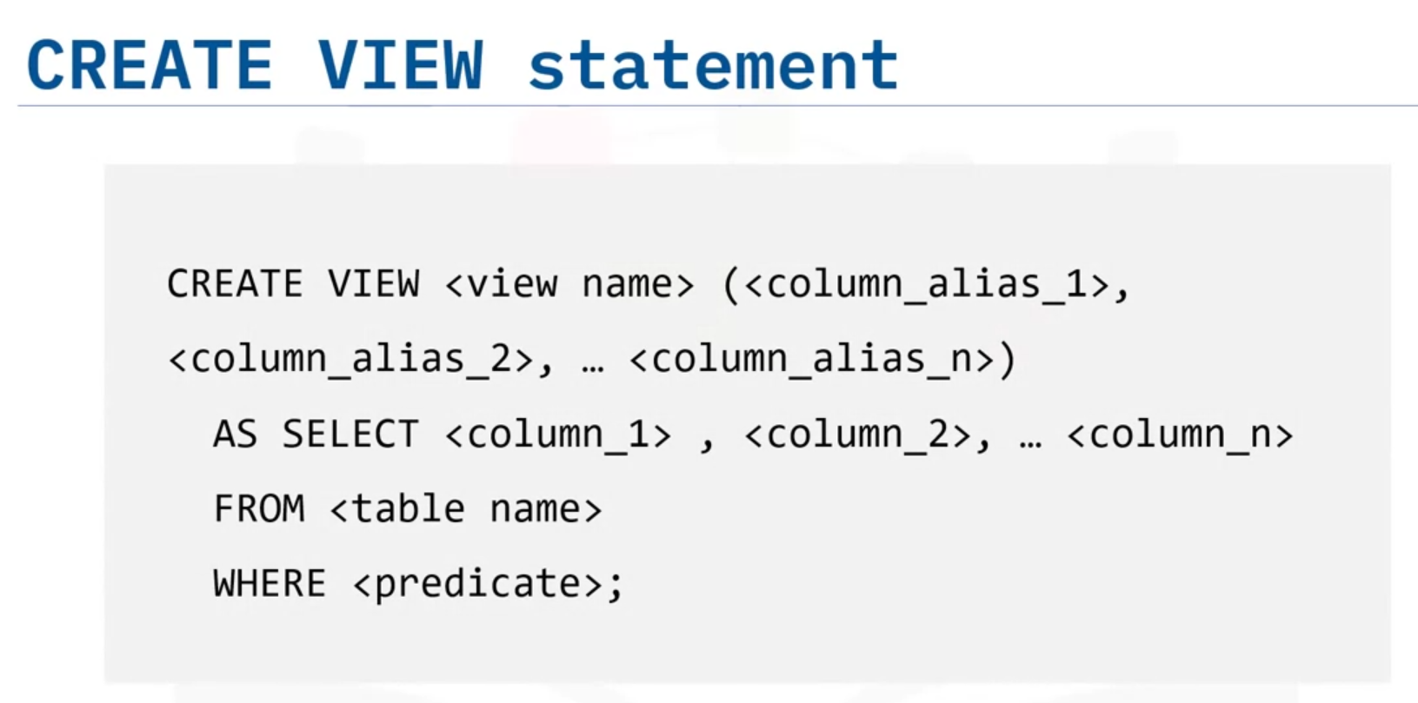

Как в питоне ты такой Х равно тому-то, то и здесь EMPINFO это такие-то колонки (имена именно колонок), а дальше указываешь запрос и там уже именно колонки указываешь.

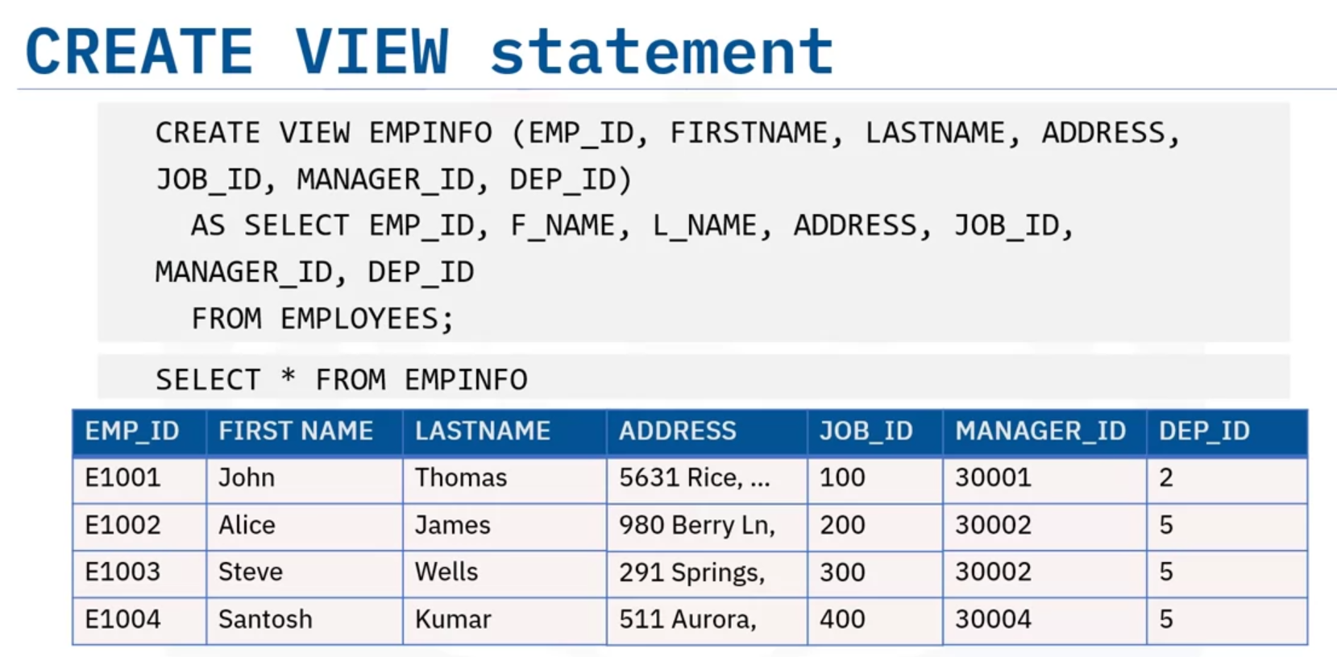

The SELECT statement that you use to create the view can name other views and tables,

and it can use the WHERE, GROUP BY, and HAVING clauses.

It cannot use the ORDER BY clause or name a host variable.

Example including WHERE:

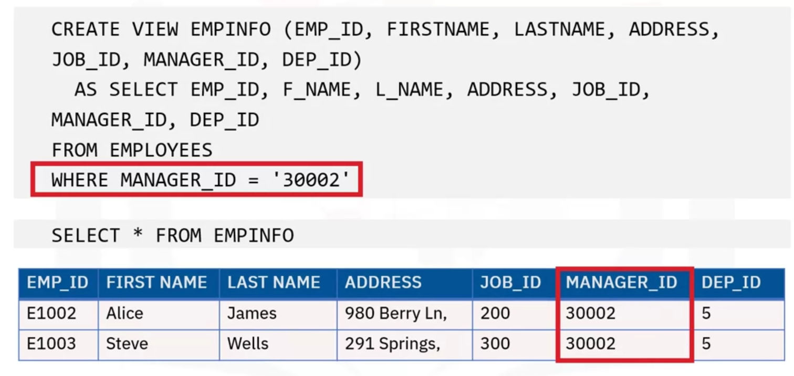

To remove a view:



Summary:

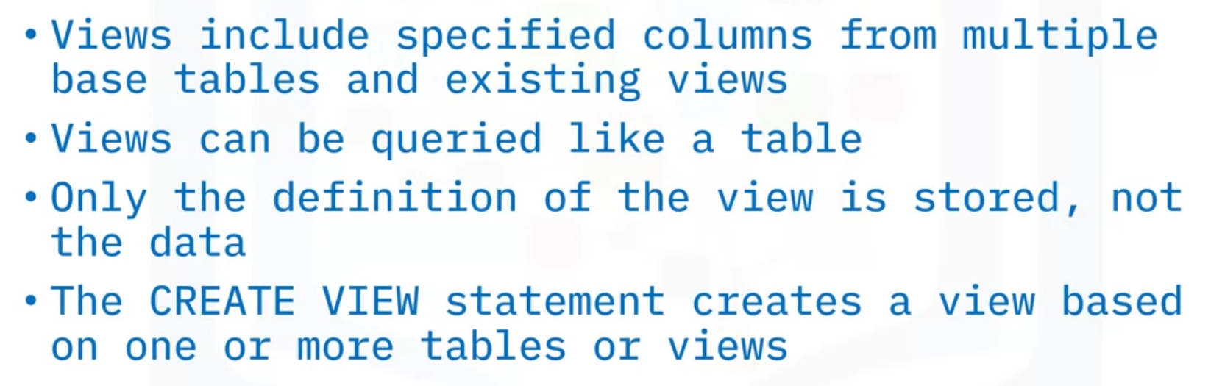

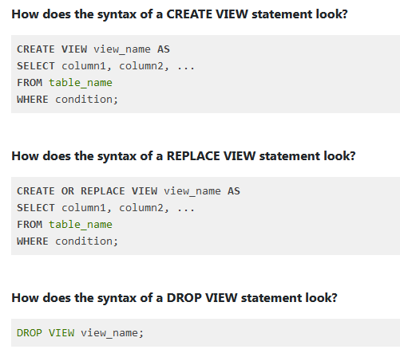

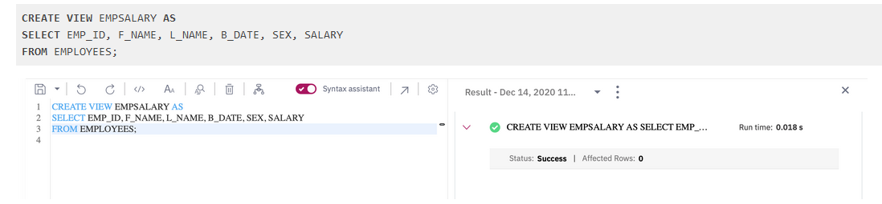

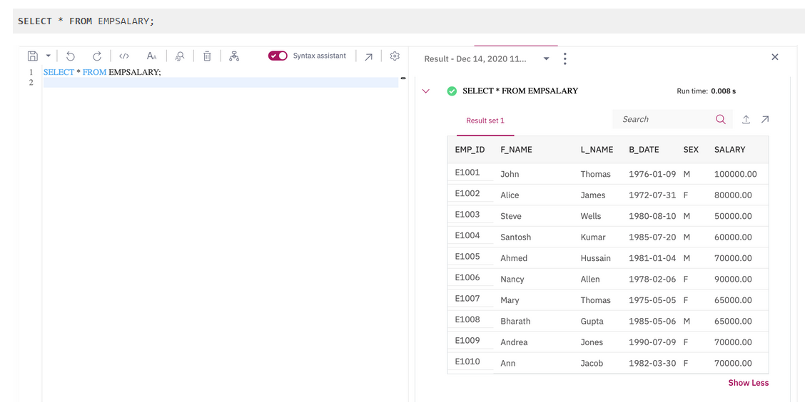

Update a view:

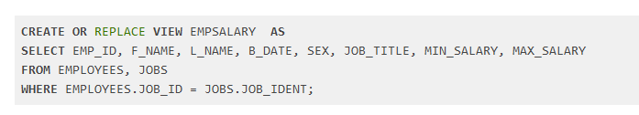

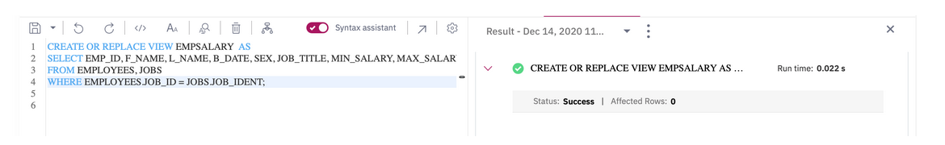

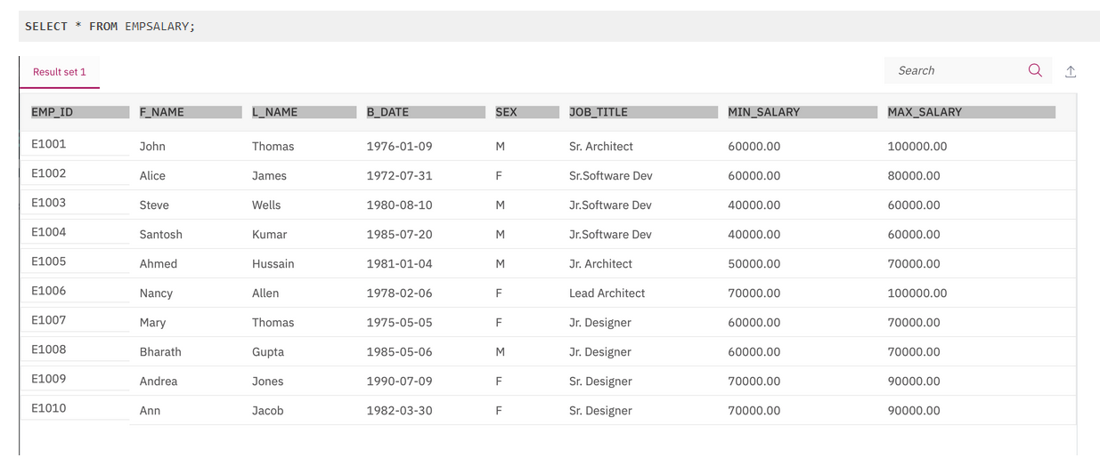

Delete a view:



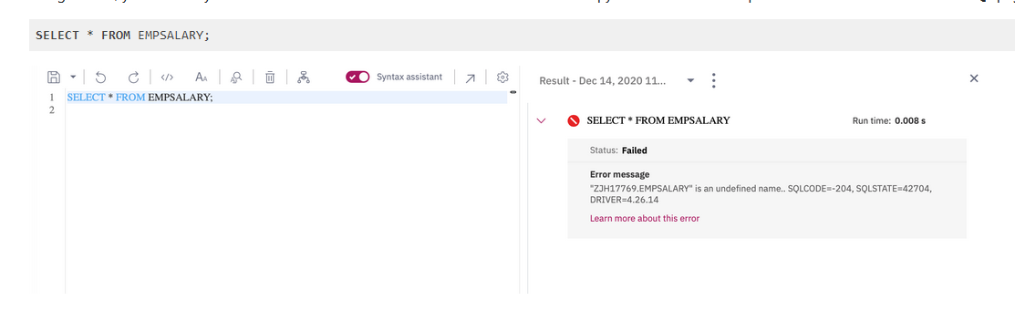

**Stored procedures**

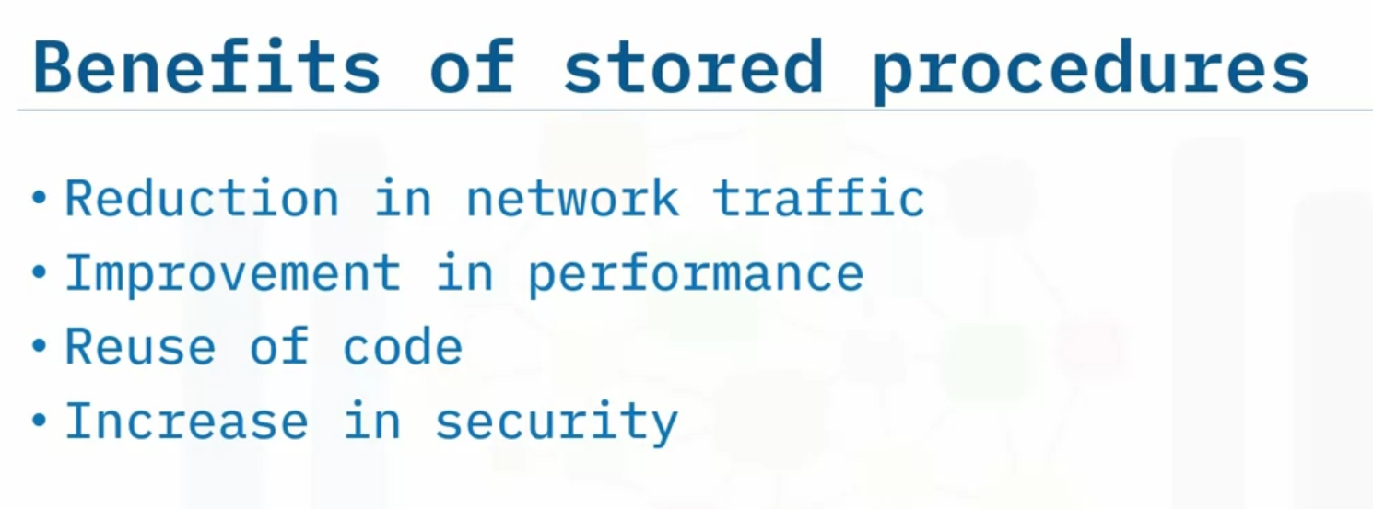

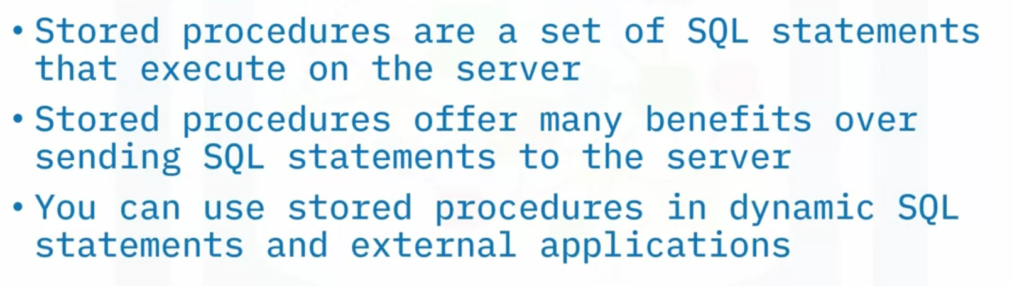

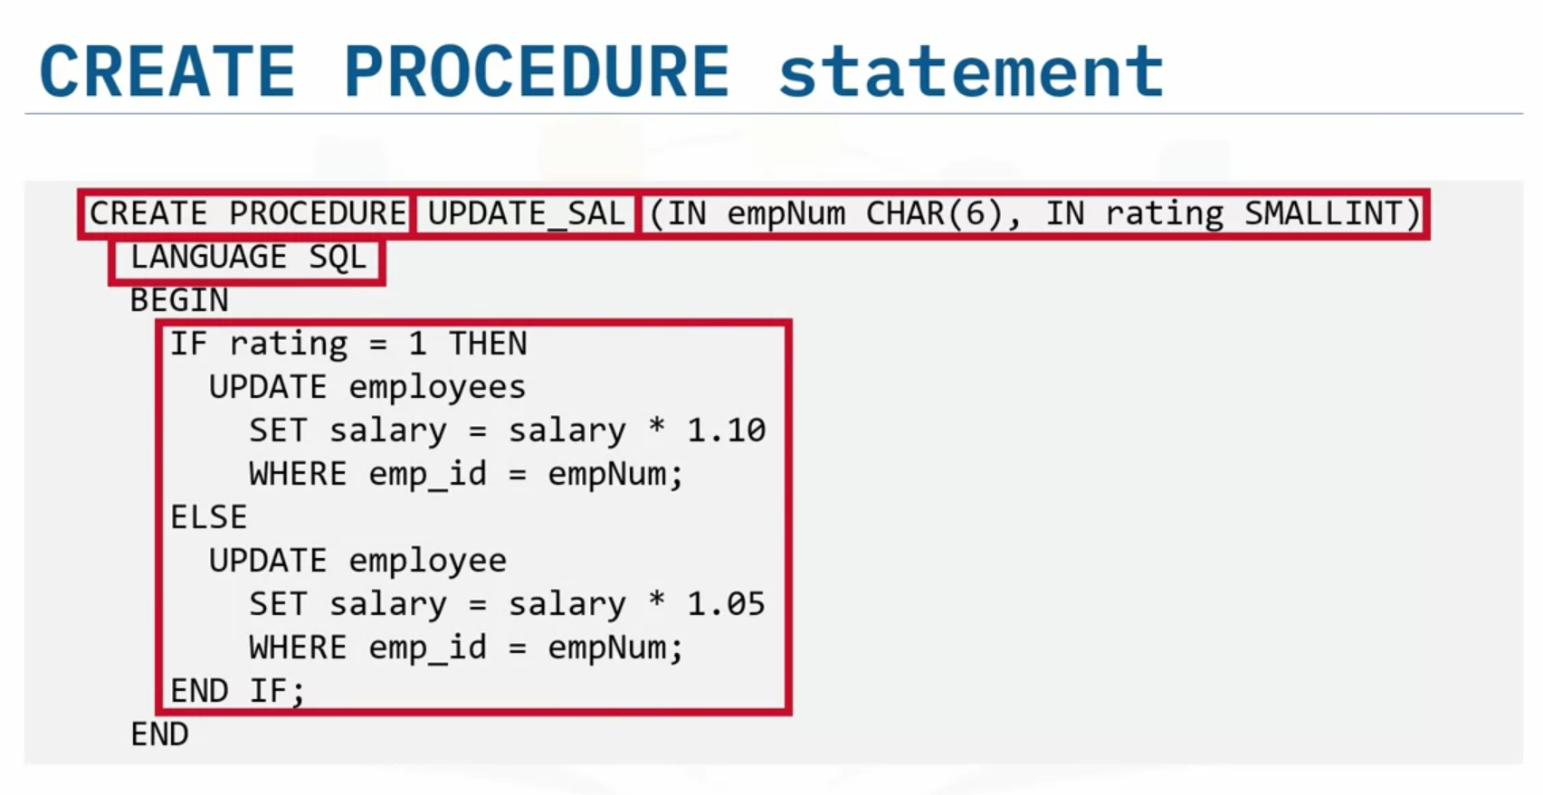

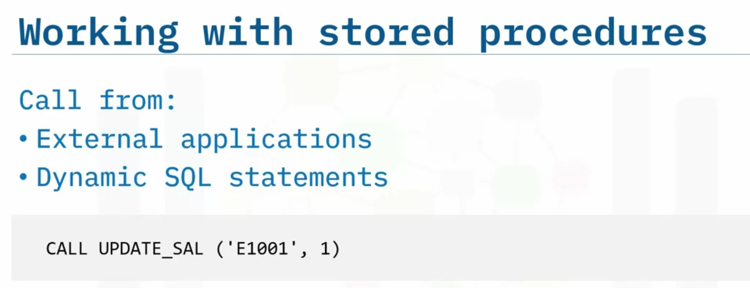

**ACID transactions**

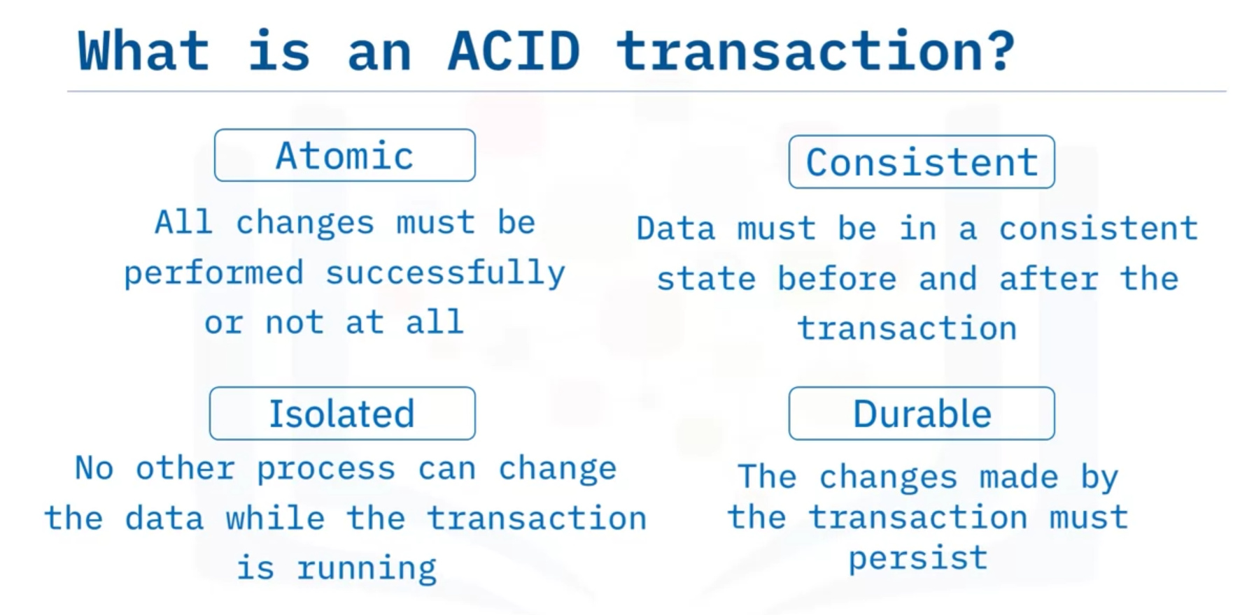

ACID transactions are Atomic - all or nothing, leave the database in a Consistent state, Isolated from any other process that changes the same data, and Durable - the changes they make are permanent.

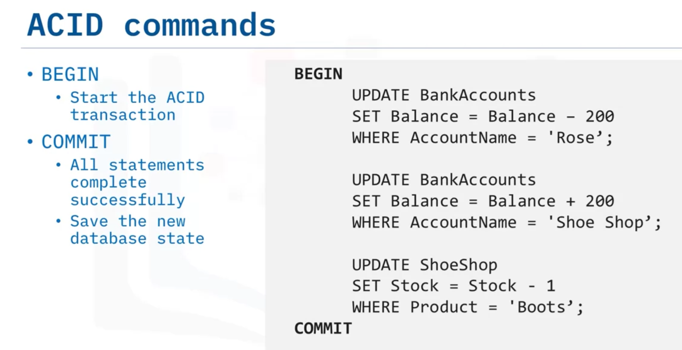

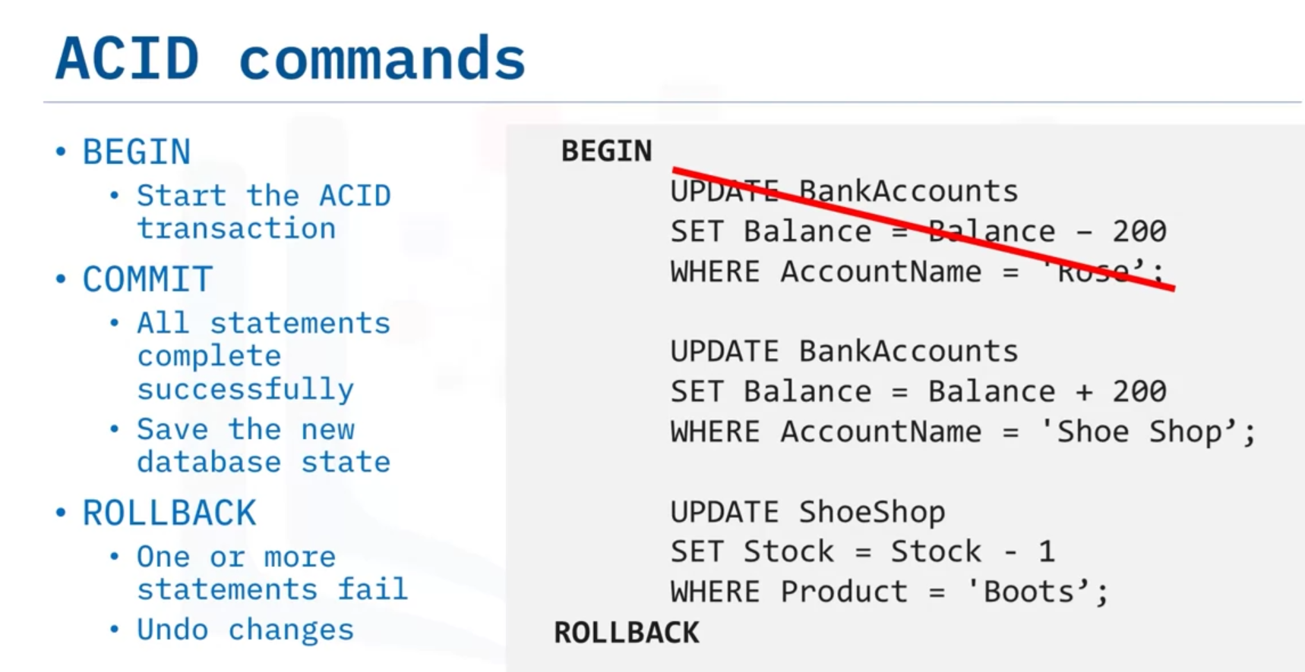

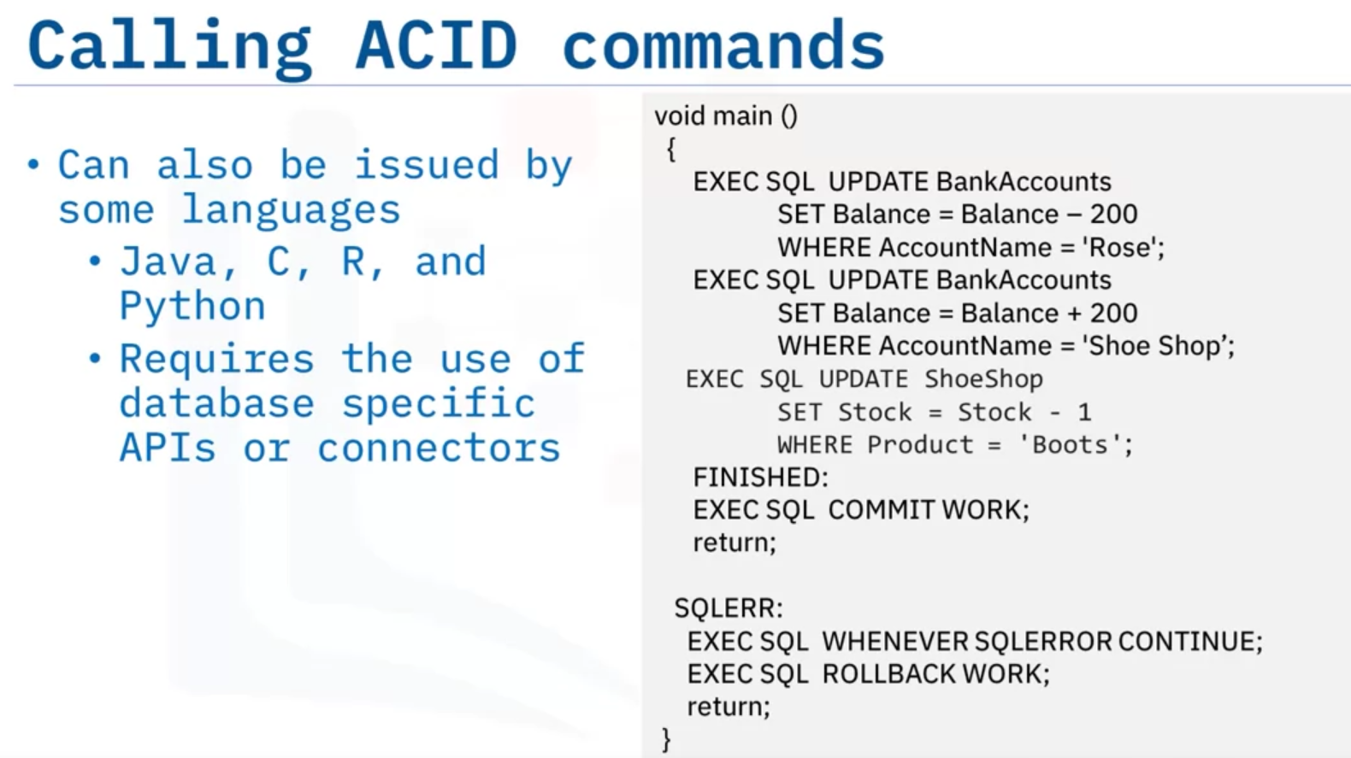

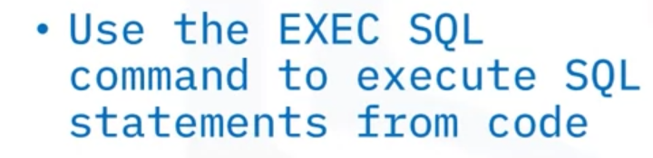

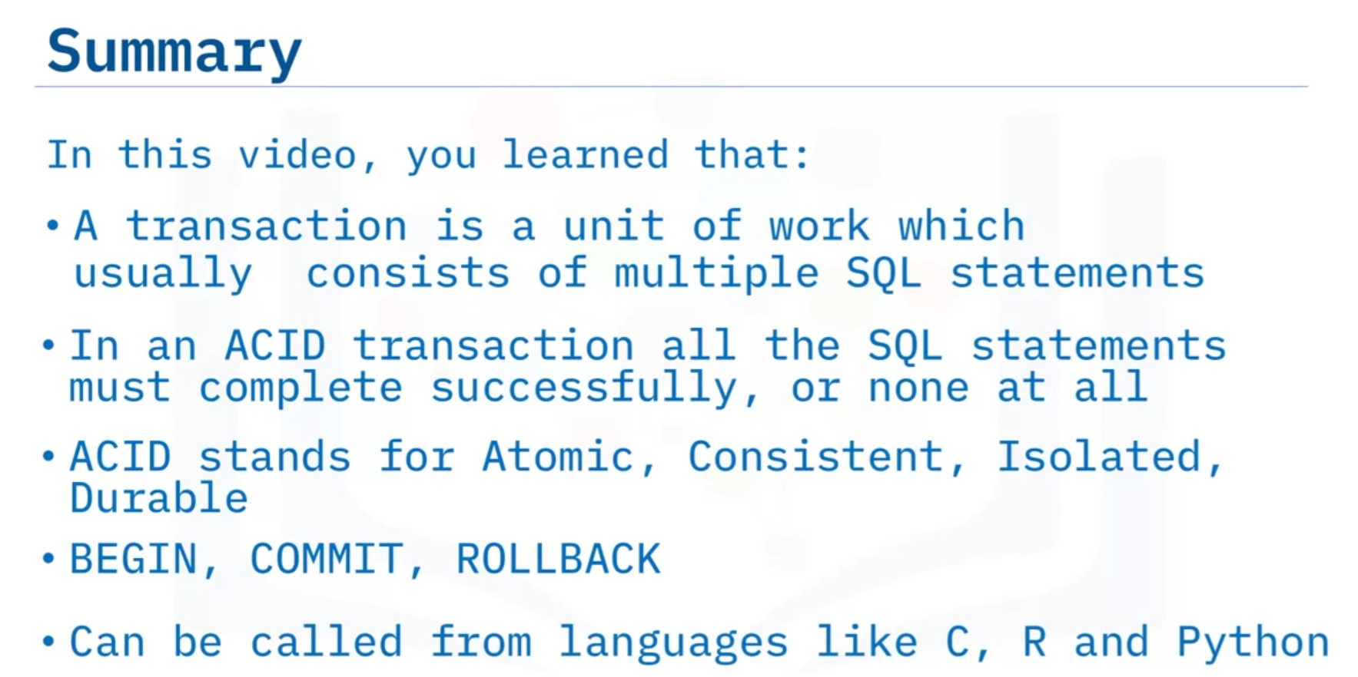

# Summary & Highlights

Congratulations! You have completed this lesson. At this point in the course, you know:

* Views are a dynamic mechanism for presenting data from one or more tables.A transaction represents a complete unit of work, which can be one or more SQL statements.
* An ACID transaction is one where all the SQL statements must complete successfully, or none at all.
* A stored procedure is a set of SQL statements that are stored and executed on the database server, allowing you to send one statement as an alternative to sending multiple statements.
* You can write stored procedures in many different languages like SQL PL, PL/SQL, Java, and C.

**Exercise**

* You will create a stored procedure routine named **RETRIEVE_ALL**.
* This **RETRIEVE_ALL** routine will contain an SQL query to retrieve all the records from the PETSALE table, so you don't need to write the same query over and over again. You just call the stored procedure routine to execute the query everytime.
* To create the stored procedure routine, copy the code below and paste it to the textbox of the **Run SQL** page. Click **Run all**.

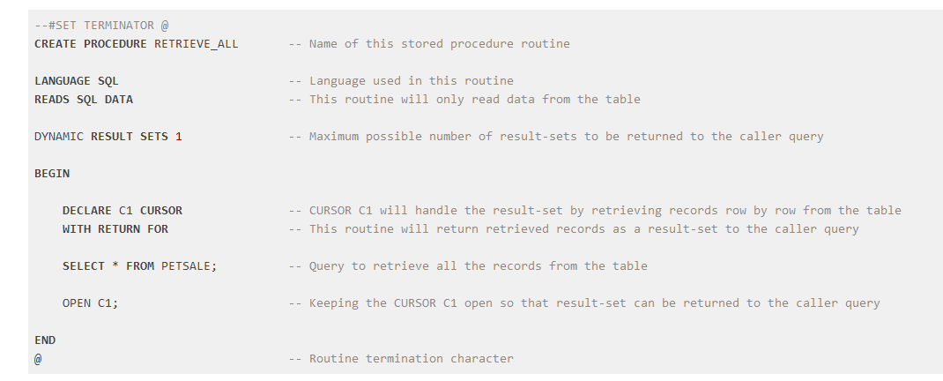

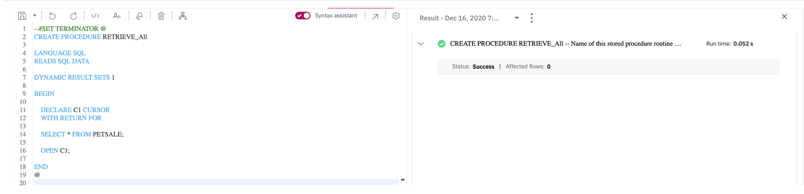

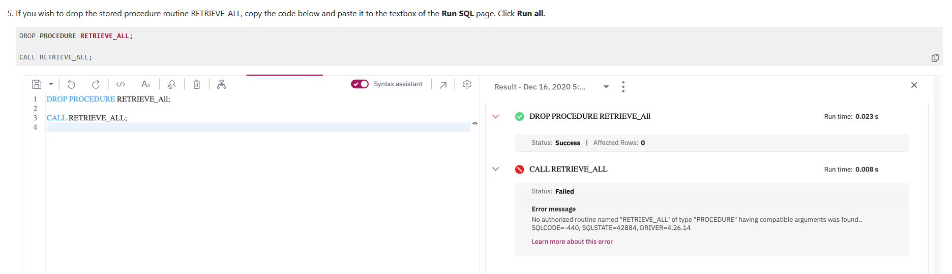

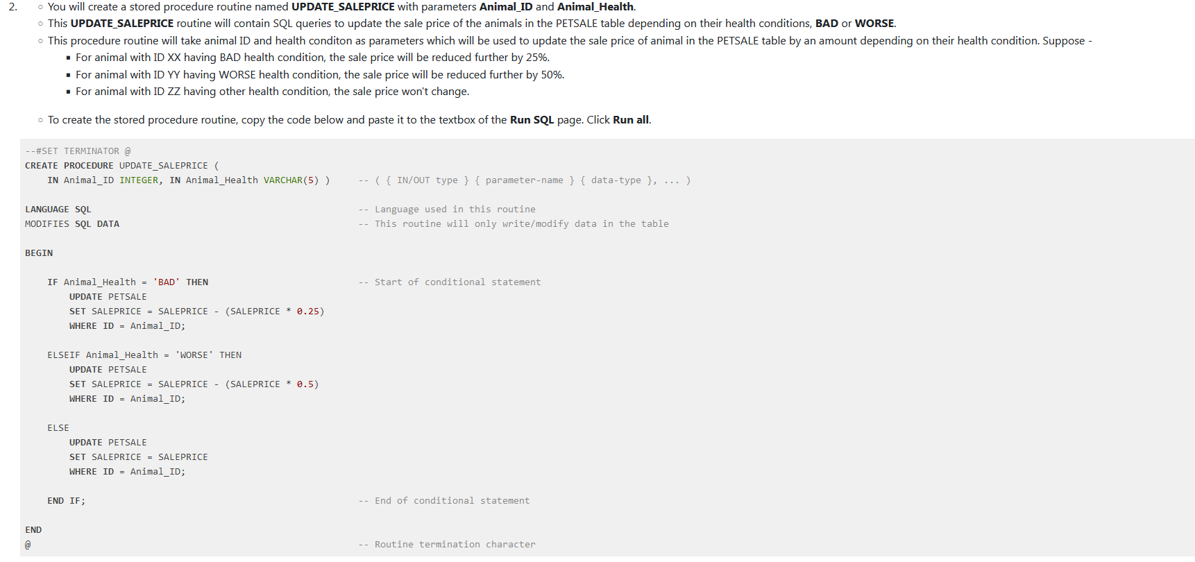

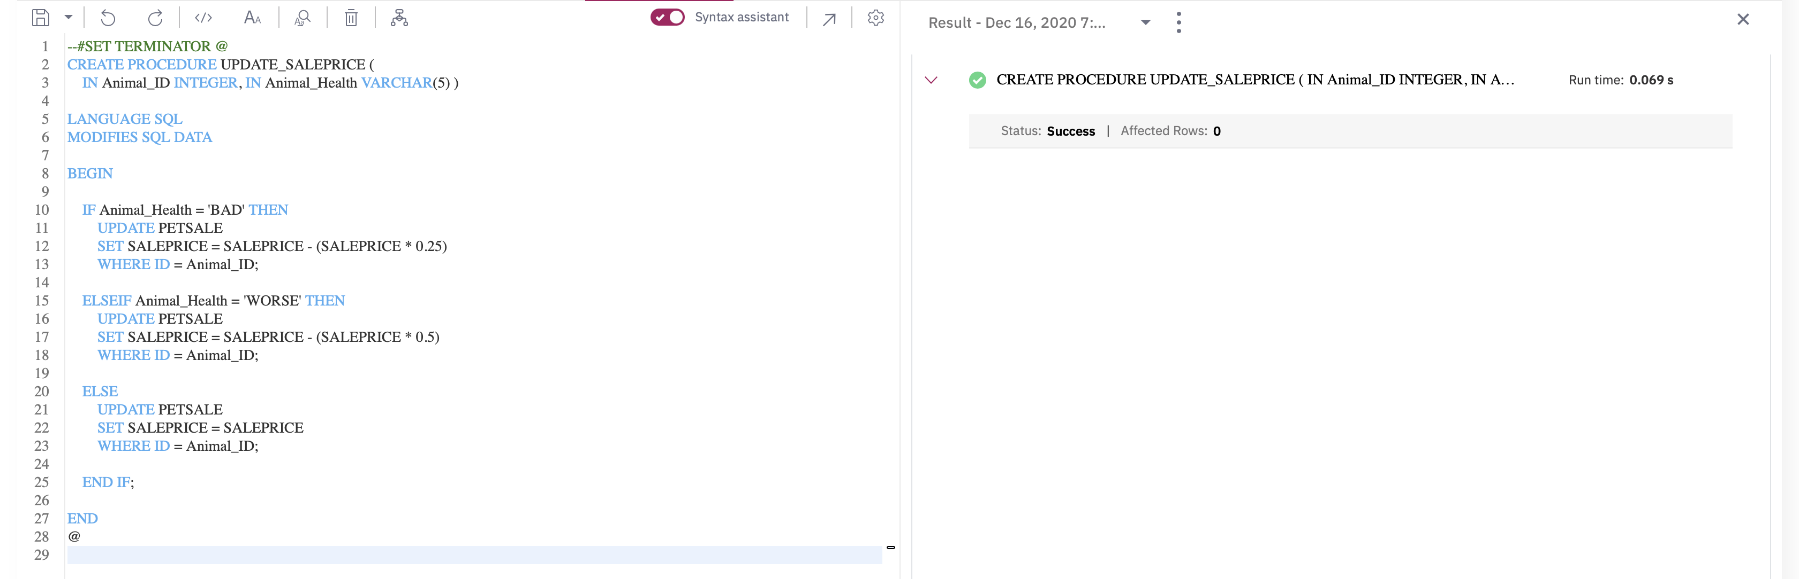

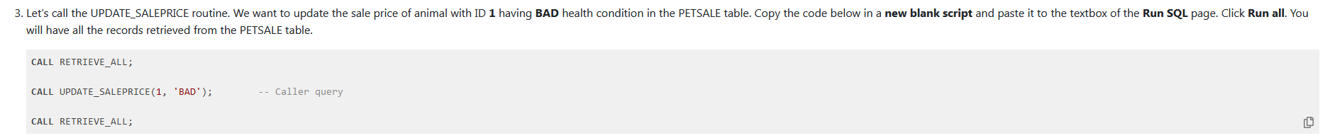

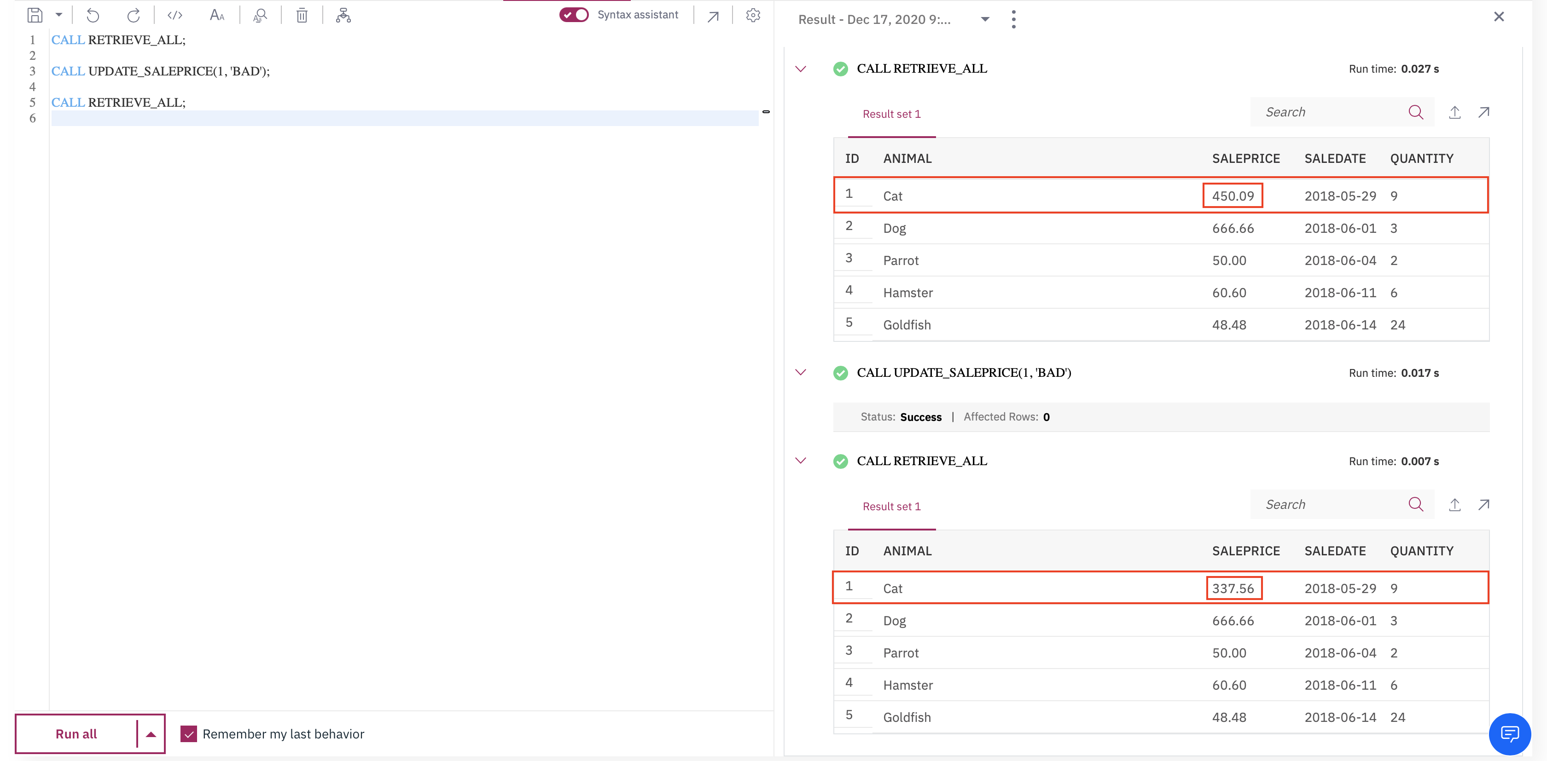



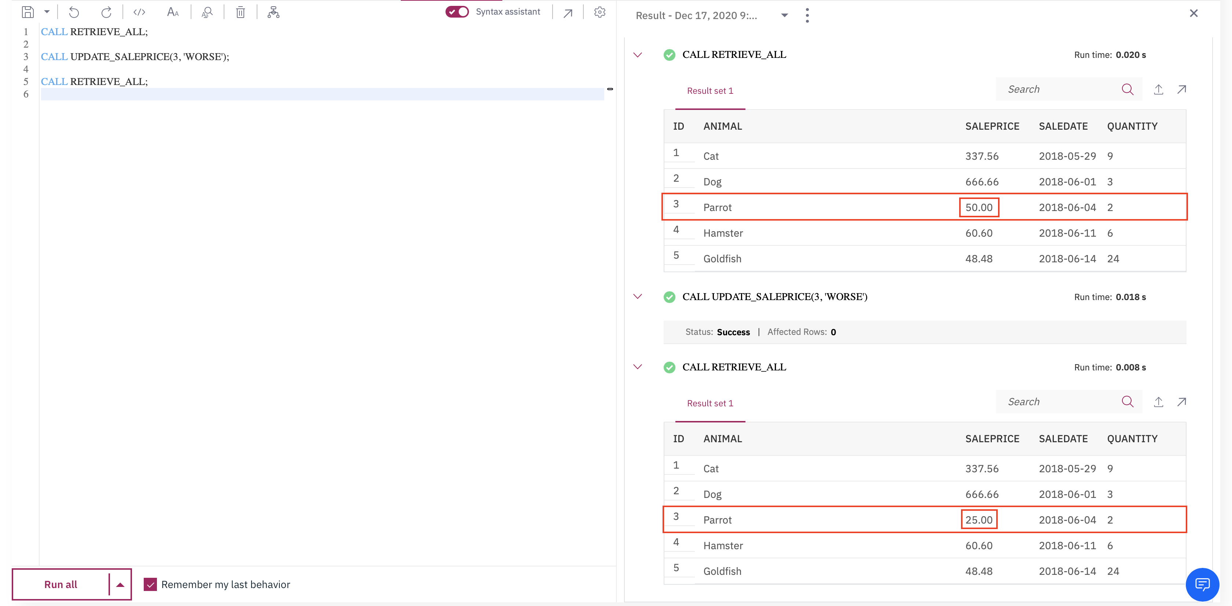

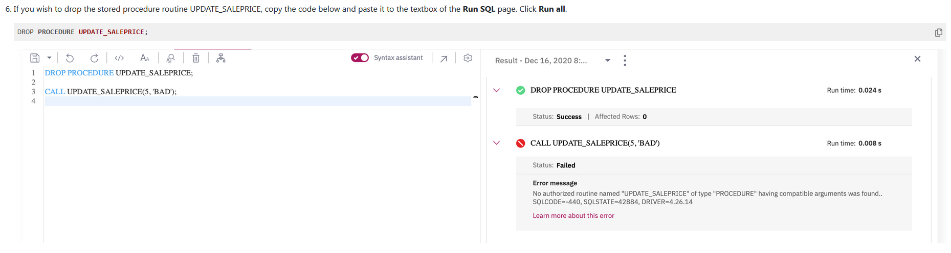

**MySQL:**

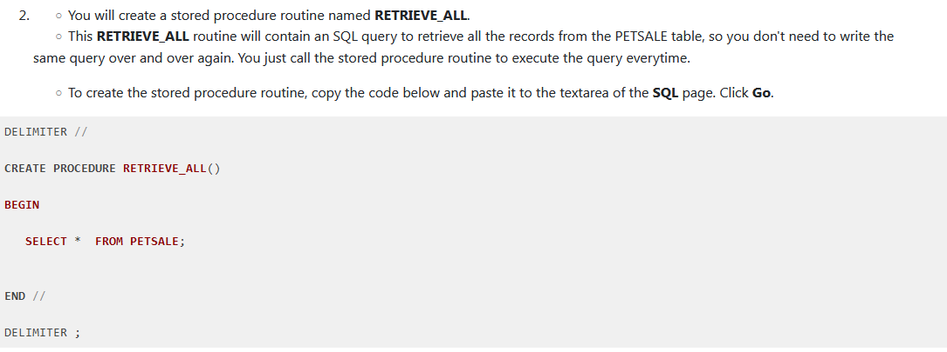

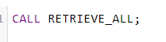

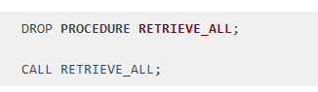

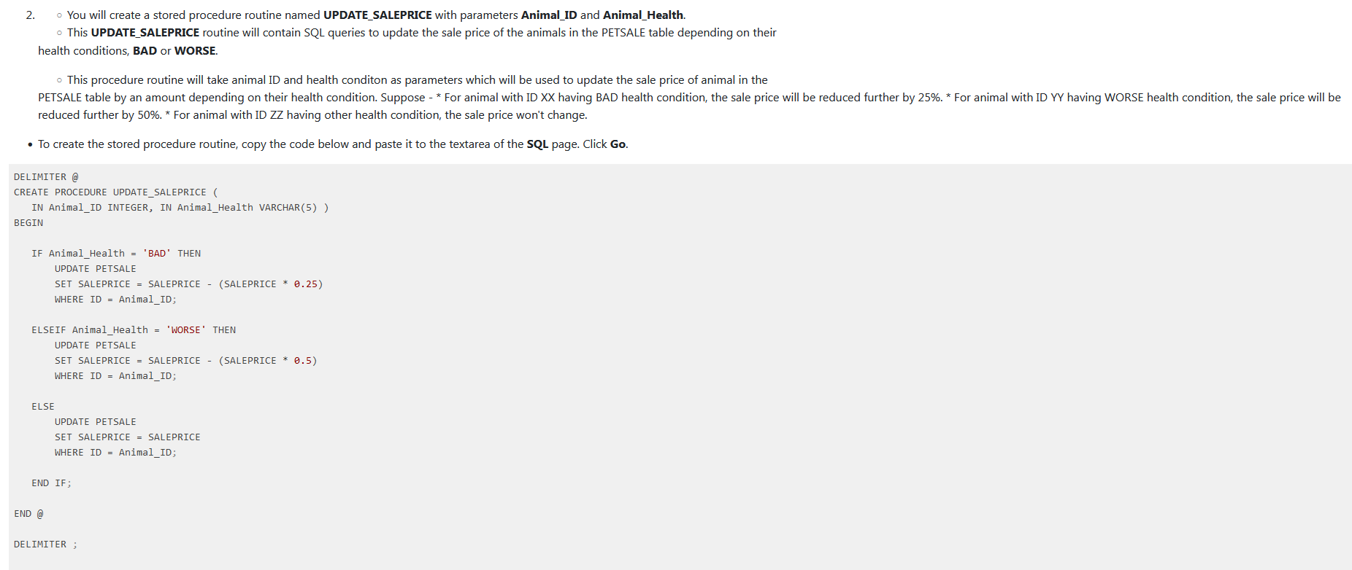

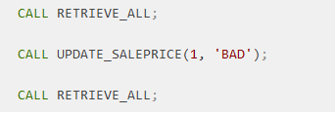

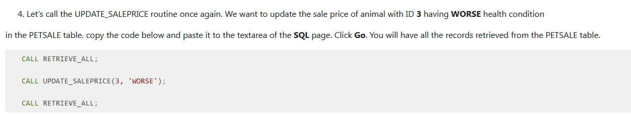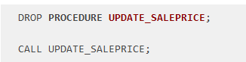

* You will create a stored procedure routine named **TRANSACTION_ROSE** which will include TCL commands like COMMIT and ROLLBACK.
* Now develop the routine based on the given scenario to execute a transaction.
* **Scenario:** Let's buy Rose a pair of Boots from ShoeShop. So we have to update the Rose balance as well as the ShoeShop balance in the BankAccounts table. Then we also have to update Boots stock in the ShoeShop table. After Boots, let's also attempt to buy Rose a pair of Trainers.
* To create the stored procedure routine on Db2, copy the code below and paste it to the textbox of the **Run SQL** page. Click **Run all**.

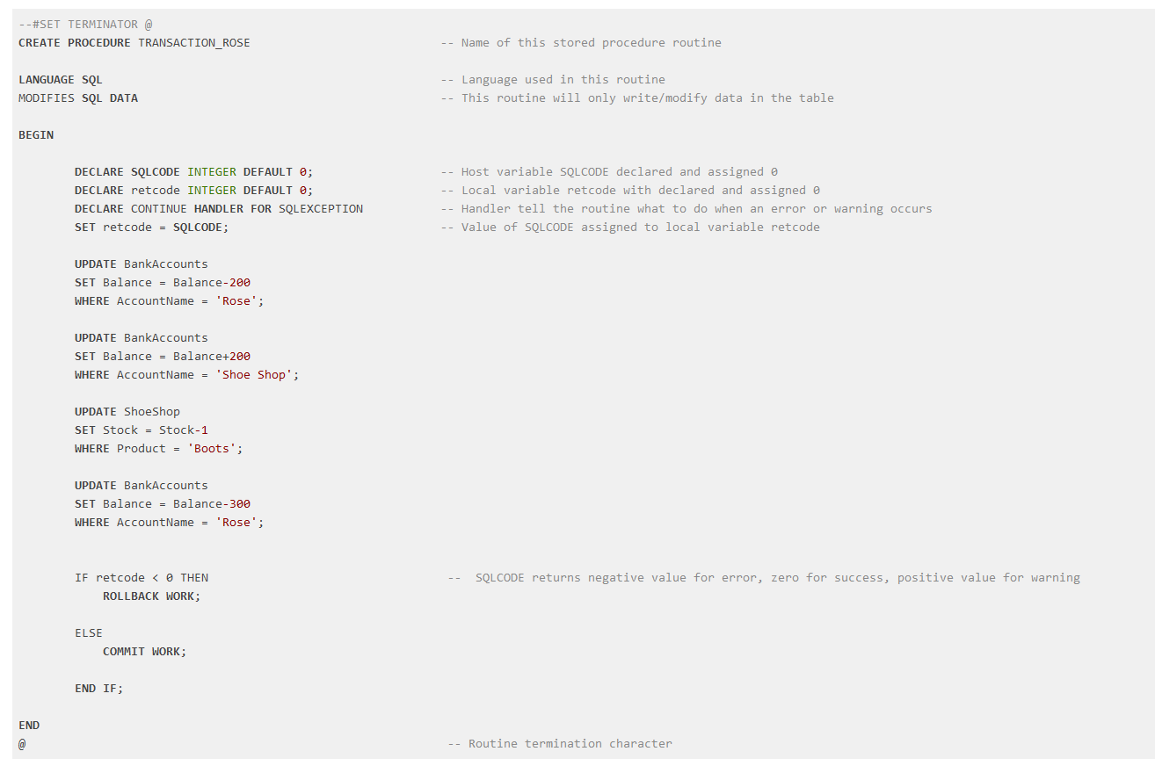

Check if the transaction can successfully be committed or not:

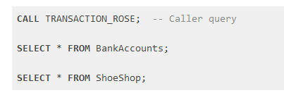

We can observe that the transaction has been executed. But when we observe the tables, no changes have permanently been saved through COMMIT. All the possible changes happened might have been undone through ROLLBACK since the whole transaction fails due to the failure of a SQL statement or more. Let's go through the possible reason behind the failure of the transaction and how COMMIT - ROLLBACK works on a stored procedure:

* The first three UPDATEs should run successfully. Both the balance of Rose and ShoeShop should have been updated in the BankAccounts table. The current balance of Rose should stand at 300 - 200 (price of a pair of Boots) = 100. The current balance of ShoeShop should stand at 124200 + 200 = 124400. The stock of Boots should also be updated in the ShoeShop table after the successful purchase for Rose, 11 - 1 = 10.
* The last UPDATE statement tries to buy Rose a pair of Trainers, but her balance becomes insufficient (Current balance of Rose: 100 < Price of Trainers: 300) after buying a pair of Boots. So, the last UPDATE statement fails. Since the whole transaction fails if any of the SQL statements fail, the transaction won't be committed.
* The **SQLCODE** which is a stand-alone host variable contains success/failure/warning information of each SQL statement execution. Now since **SQLCODE** variable gets reset back as the next SQL statement runs, **retcode** is our local variable to catch the return value of this **SQLCODE**. **SQLCODE** returns negative value for each SQL statement if not executed successfully. So, on any error occurrence, all the changes are rolled back. Commit only takes place after the transaction gets executed successfully without any error.

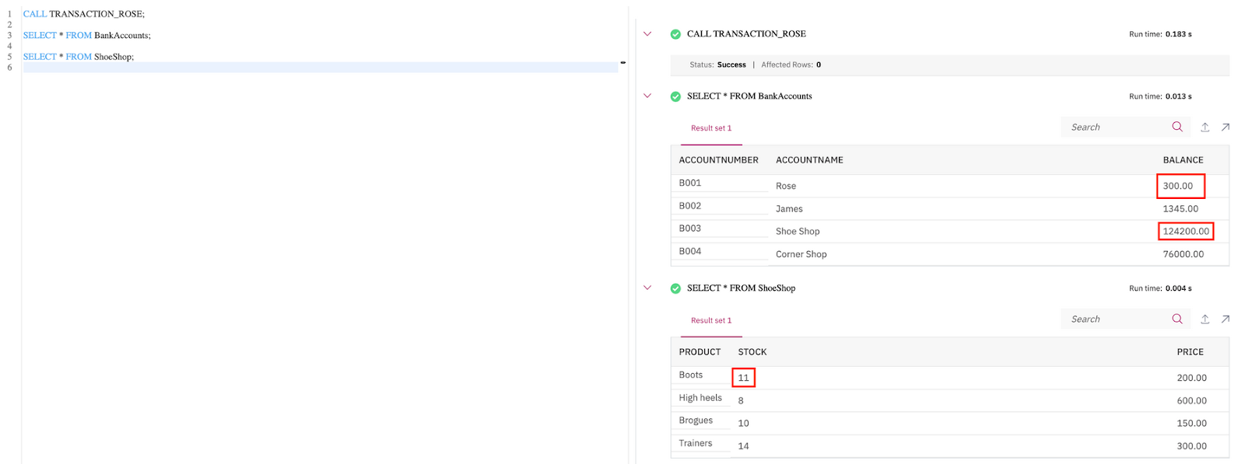

*Create a stored procedure* ***TRANSACTION_JAMES*** *to execute a transaction based on the following scenario: First buy James 4 pairs of Trainers from ShoeShop. Update his balance as well as the balance of ShoeShop. Also, update the stock of Trainers at ShoeShop. Then attempt to buy James a pair of Brogues from ShoeShop. If any of the UPDATE statements fail, the whole transaction fails. You will roll back the transaction. Commit the transaction only if the whole transaction is successful.*

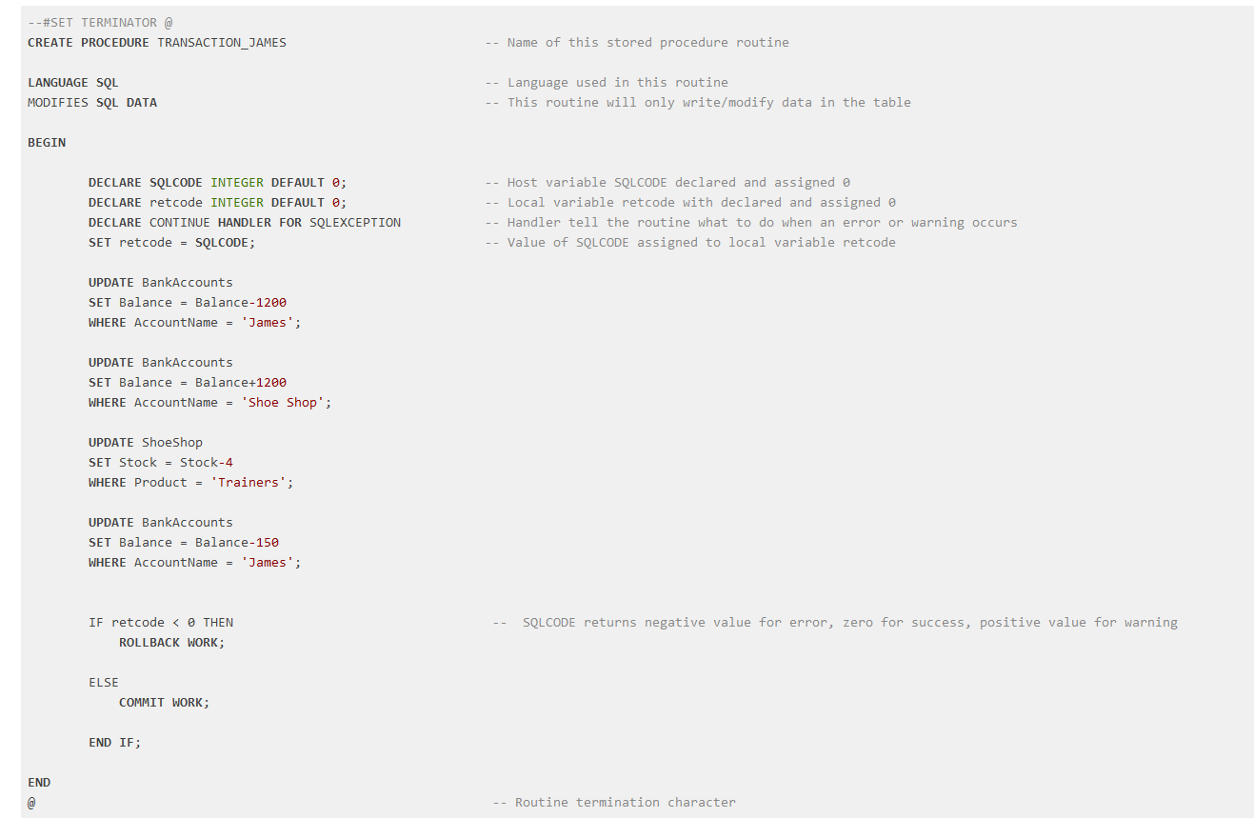

**MySQL**

* You will create a stored procedure routine named **TRANSACTION_ROSE** which will include TCL commands like COMMIT and ROLLBACK.
* Now develop the routine based on the given scenario to execute a transaction.
* **Scenario:** Let's buy Rose a pair of Boots from ShoeShop. So we have to update the Rose balance as well as the ShoeShop balance in the BankAccounts table. Then we also have to update Boots stock in the ShoeShop table. After Boots, let's also attempt to buy Rose a pair of Trainers.
* To create the stored procedure routine on Db2, copy the code below and paste it to the textarea of the **SQL** page. Click **Go**.

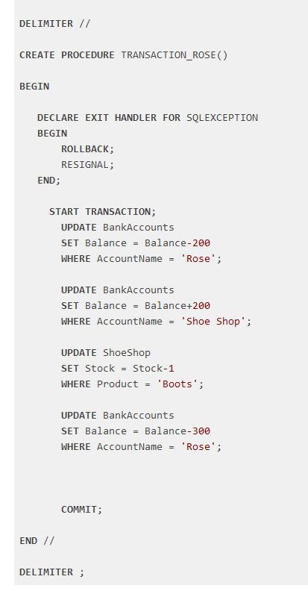

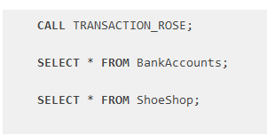

We can observe that the transaction has been executed. But when we observe the tables, no changes have permanently been saved through COMMIT. All the possible changes happened might have been undone through ROLLBACK since the whole transaction fails due to the failure of a SQL statement or more. Let's go through the possible reason behind the failure of the transaction and how COMMIT - ROLLBACK works on a stored procedure:

* The first three UPDATEs should run successfully. Both the balance of Rose and ShoeShop should have been updated in the BankAccounts table. The current balance of Rose should stand at 300 - 200 (price of a pair of Boots) = 100. The current balance of ShoeShop should stand at 124200 + 200 = 124400. The stock of Boots should also be updated in the ShoeShop table after the successful purchase for Rose, 11 - 1 = 10.
* The last UPDATE statement tries to buy Rose a pair of Trainers, but her balance becomes insufficient (Current balance of Rose: 100 < Price of Trainers: 300) after buying a pair of Boots. So, the last UPDATE statement fails. Since the whole transaction fails if any of the SQL statements fail, the transaction won't be committed.

*Create a stored procedure* ***TRANSACTION_JAMES*** *to execute a transaction based on the following scenario: First buy James 4 pairs of Trainers from ShoeShop. Update his balance as well as the balance of ShoeShop. Also, update the stock of Trainers at ShoeShop. Then attempt to buy James a pair of Brogues from ShoeShop. If any of the UPDATE statements fail, the whole transaction fails. You will roll back the transaction. Commit the transaction only if the whole transaction is successful.*

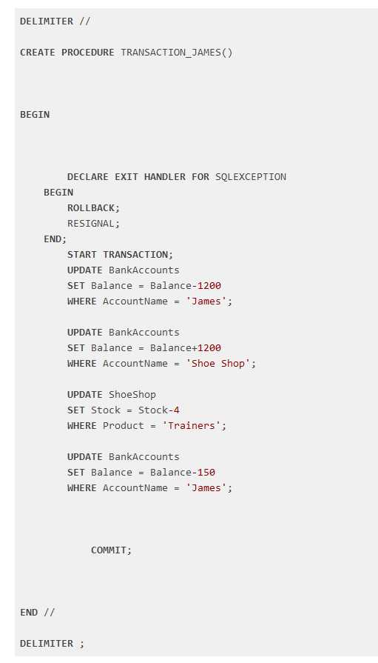

**JOINs**

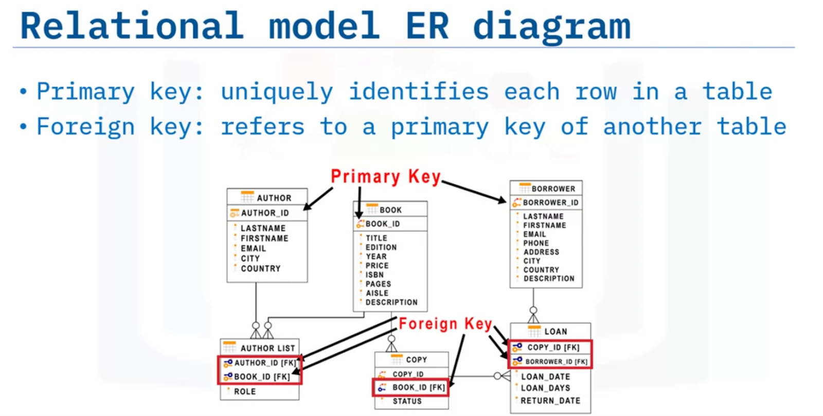

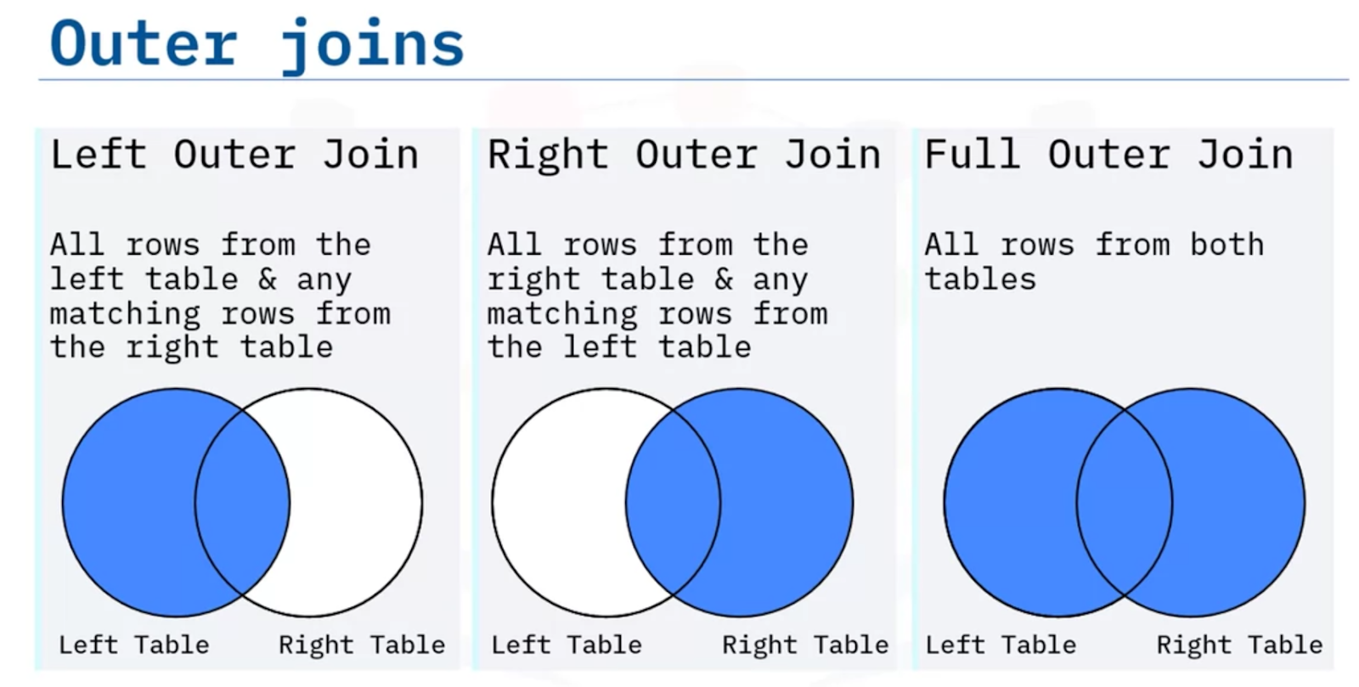

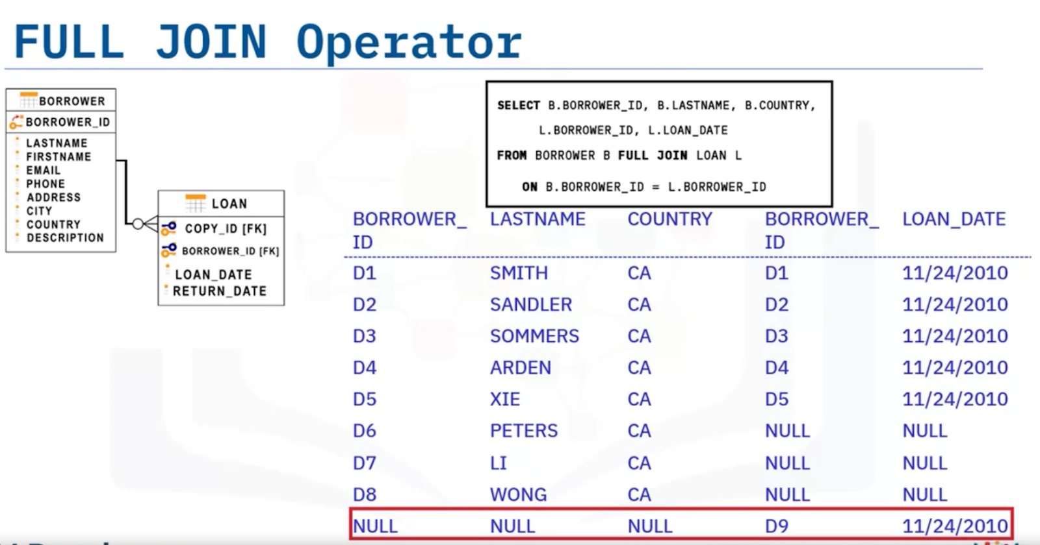

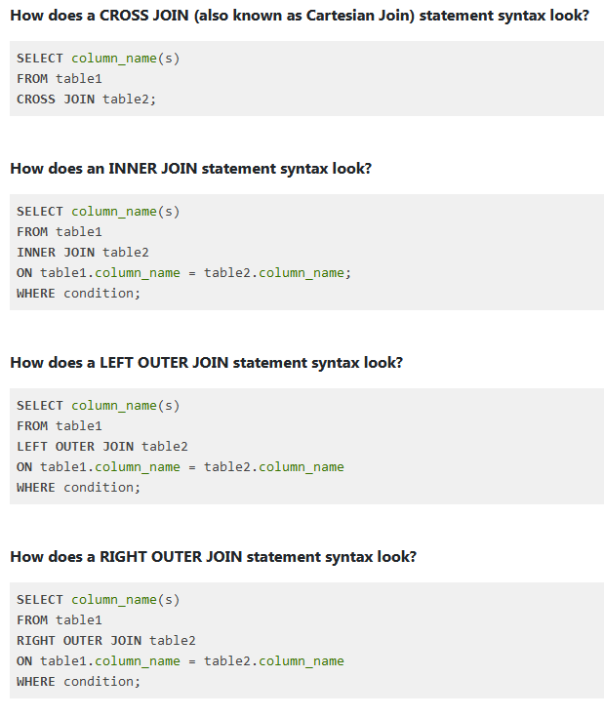

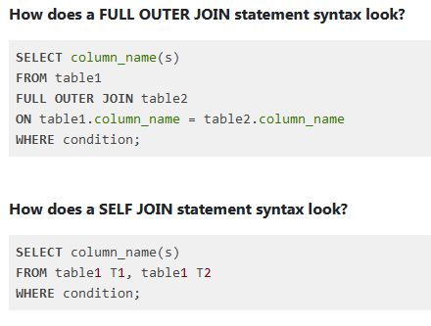

**MySQL**

